**Question 1: You need to create an Azure Virtual Network (VNet) to host a set of virtual machines (VMs) for a new application. The VNet should have a CIDR range of 10.0.0.0/16 and be divided into two subnets: one for web servers and one for database servers.**

ANS: Instead of performing on Azure I did perform the task on Amazon AWS**. (Vnet = VPC)**

1. First Create a new virtual network
2. **Open the AWS portal and navigate to the ALL THE SERVICES**
3. Click on create a new virtual network
4. Enter a name for the virtual network **(MYVPC)**
5. Enter the CIDR range (10.0.0.0/16)
6. Click on "Create" to create the VPC
7. Create two subnets within the VPC
8. Navigate to the newly created VPC
9. Click on "Subnets" and then "Add subnet"
10. Enter a name for the first subnet (e.g. FIRST)
11. Enter a CIDR range for the first subnet (e.g. 10.0.0.0/24)
12. Click on "CREATE" to create the first subnet
13. Repeat the process to create a second subnet with a different name (e.g. SECOND) and CIDR range (e.g. 10.0.1.0/24)

**HERE ARE THE SOME SCREENSHOTS OF THE VPC AND SUBNETS.**

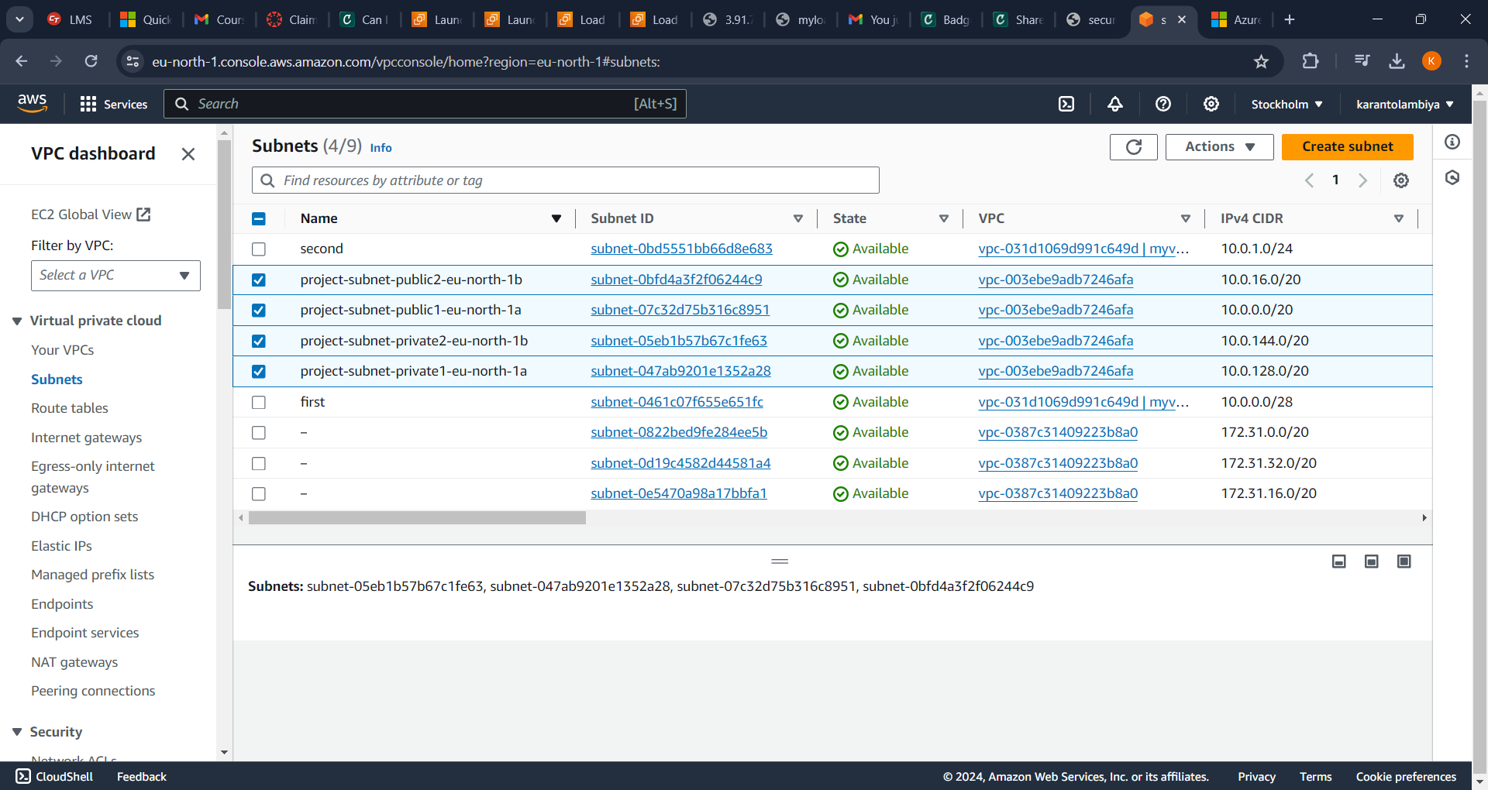

* SUBNETS

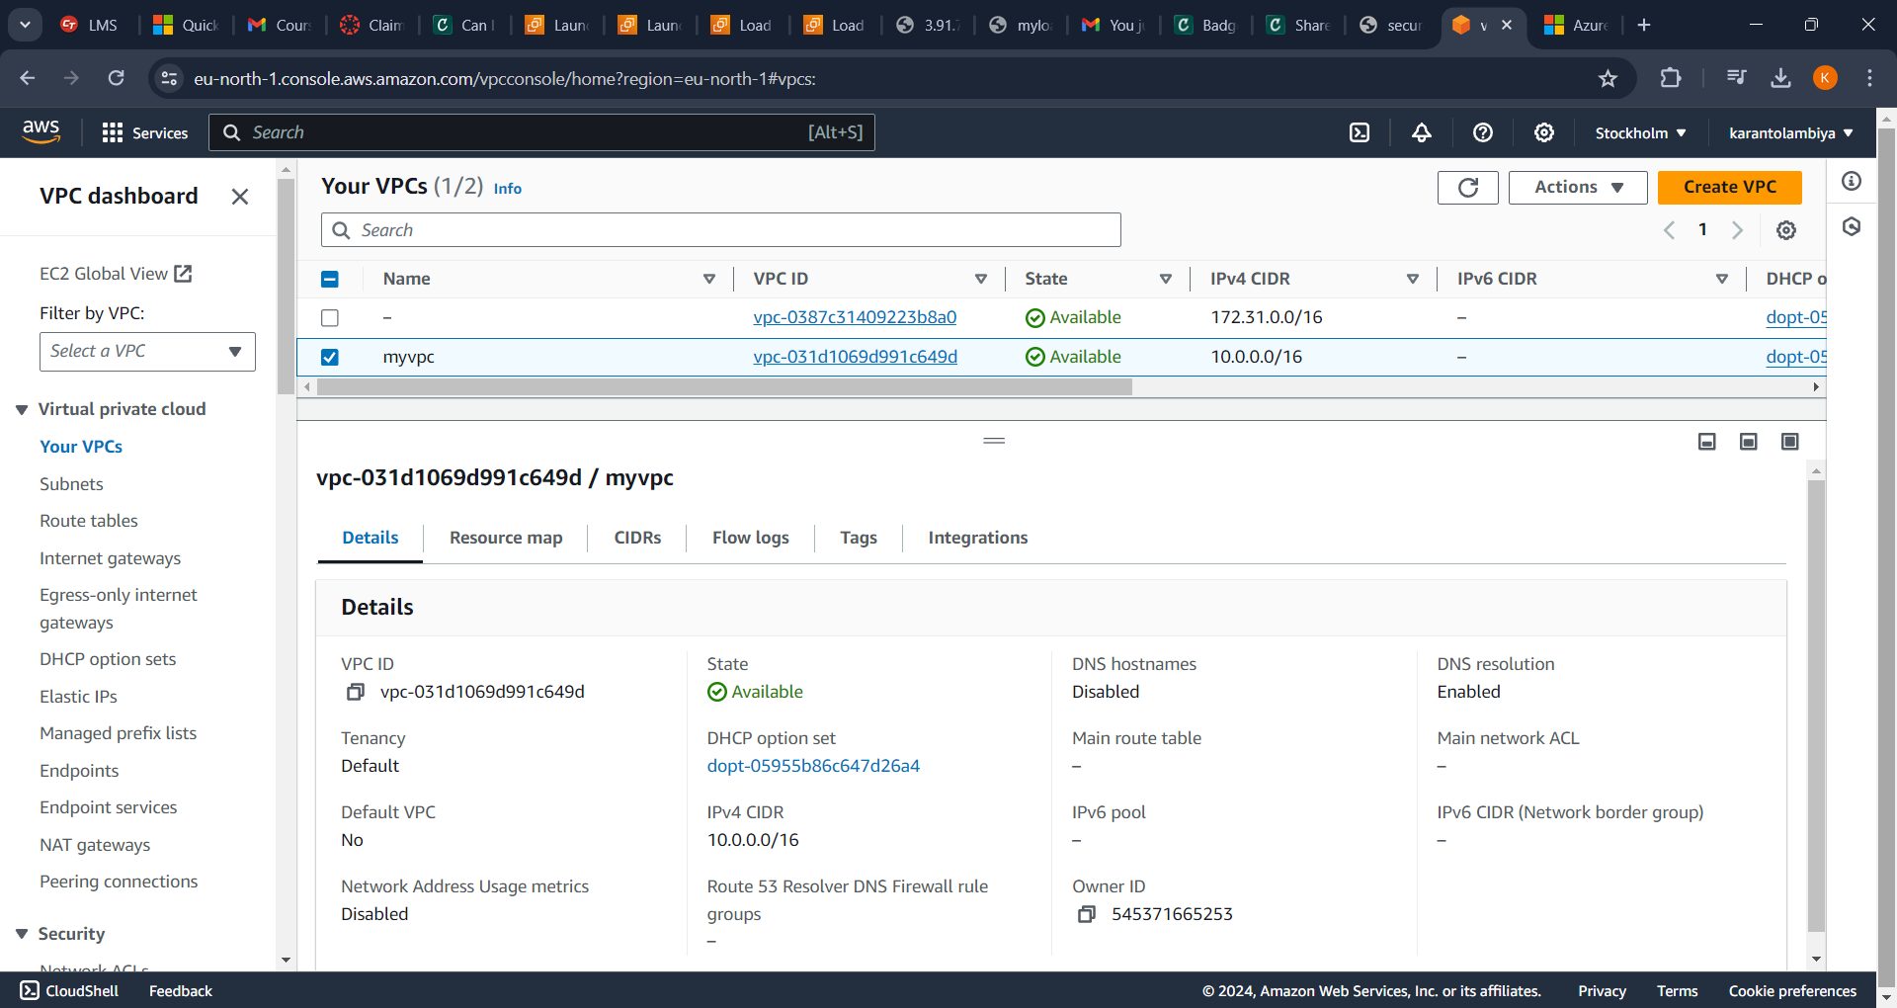

* VPC